|  |  |
| --- | --- |
|  | **AMERICAN INTERNATIONAL UNIVERSITY-BANGLADESH (AIUB)**  Faculty of Engineering  Department of EEE and CoE  Undergraduate Program |





|  |  |
| --- | --- |
| **Course:** Introduction To Electric Circuit | **Exp No: 09** Fall :2021 |

|  |
| --- |
| **Title:** Analysis of RLC parallel circuit and verification of KCL in AC circuits. |

Submitted by

|  |  |  |  |
| --- | --- | --- | --- |
| **Name** | **ID** | **Signature** | **Contact Details** |
| Ankon Sarker linkon | 19-40895-2 | Ankon | 01767553784 |

Group Members:

|  |  |  |  |
| --- | --- | --- | --- |
| **SL** | **Name** | **ID** | **Signature** |
| 01 | Ankon Sarker linkon | 19-40895-2 |  |
| 02 | Himel Datta | 19-41576-3 |  |

**Due Date: Submission Date:22.11.21**



**Submitted To**

**FACULTY NAME**

Faculty of Engineering

Department of EEE  
American International University-Bangladesh

Title: Analysis of RLC parallel circuit and verification of KCL in AC circuits.

Introduction: The objectives of this experiment are-

• To determine phase relationship between IL and IC in a RLC parallel circuit.

• Draw the complete vector diagram for a RLC parallel circuit.

• Verification of KCL in AC circuits.

Theory and Methodology: In dc circuits, conductance (G) was defined as being equal to 1/R. The total conductance of a parallel circuit was then found by adding the conductance of each branch. The total resistance RT is simply1/GT. In ac circuits, we define admittance (Y) as being equal to 1/Z. The unit of measure for admittance as defined by the SI system is Siemens, which has the symbol S. Admittance is a measure of how well an Ac circuit will admit, or allow, current to flow in the circuit. The larger its value, therefore, the heavier the current flow for the same applied potential. The total admittance of a circuit can also be found by finding the sum of the parallel admittances. The total impedance ZT of the circuit is then 1/YT; that is, for the network of Fig.

𝑌𝑇 = 𝑌1 + 𝑌2 + 𝑌3 + … … … … + 𝑌N

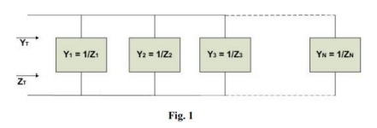

Or, Since Z = 1/Y,

1/𝑍𝑇=1/𝑍1+1/𝑍2+1/𝑍3+ . . . . . . . . . . . +1/𝑍N

For two impedances in parallel,

1/𝑍𝑇=1/𝑍1+1/𝑍2

𝑍𝑇 =𝑍1𝑍2/(𝑍1 + 𝑍2)

For three parallel impedances,

𝑍𝑇 =𝑍1𝑍2𝑍3/(𝑍1𝑍2 + 𝑍2𝑍3 + 𝑍1𝑍3) As pointed out in the introduction to this section, conductance is the reciprocal of resistance, and

𝑌𝑅 =1/𝑍𝑅=1/𝑅∠0° = 𝐺∠0°

The reciprocal of reactance (1/X) is called susceptance and is a measure of how susceptible an element is to the passage of current through it. Susceptance is also measured in Siemens and is represented by the capital letter B. For the inductor,

𝑌𝐿 =1/𝑍𝐿=1/𝑋𝐿∠90° =1/𝑋𝐿(∠ − 90°)

Defining 𝐵𝐿 =1/𝑋𝐿 (siemens, S)

𝑌𝐿 = 𝐵𝐿 ∠ − 90°

Note that for inductance, an increase in frequency or inductance will result in a decrease in susceptance or, correspondingly, in admittance.

For the capacitor,

𝑌𝐶 = 1/𝑍𝐶 = 1/(𝑋𝐶∠ − 90 °) = 1/𝑋𝐶 ∠90°

Defining 𝐵𝐶 = 1/𝑋𝐶 (semens, S) 𝑌𝐶 = 𝐵𝐶 ∠90°

For the capacitor, therefore, an increase in frequency or capacitance will result in an increase in its susceptibility. For any configuration (series, parallel, seriesparallel, etc.), the angle associated with the total admittance is the angle by which the source current leads the applied voltage. For inductive networks, 𝜃𝑇 is negative, whereas for capacitive networks, 𝜃𝑇 is positive.

Apparatus:

• Oscilloscope

• Function generator

• Resistor: 100 Ω (3)

• Inductor: 6.3 mH

• Capacitor: 1uF

• Connecting wire.

• Bread board

Given Circuit:

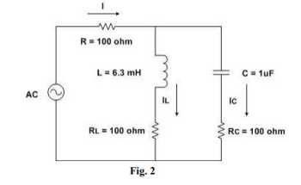

Simulation & Result:

For Fig-01:

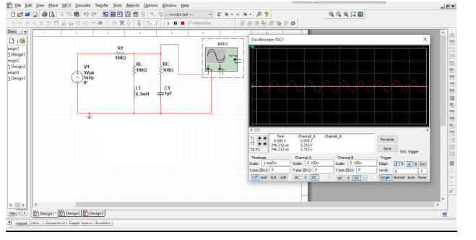

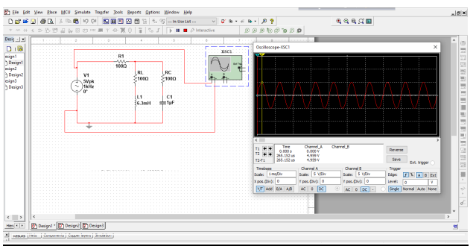

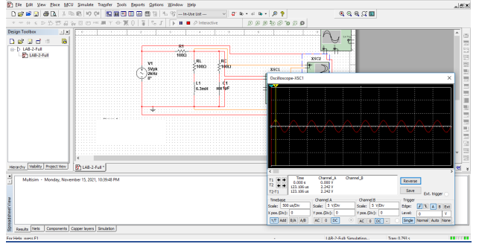

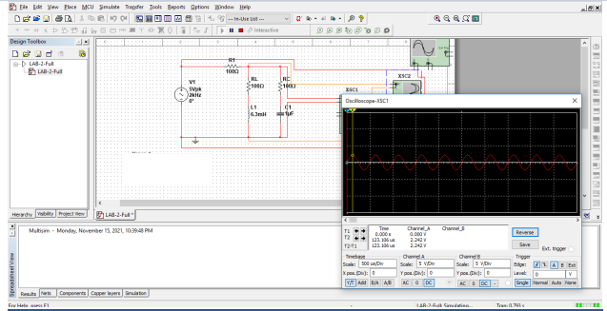

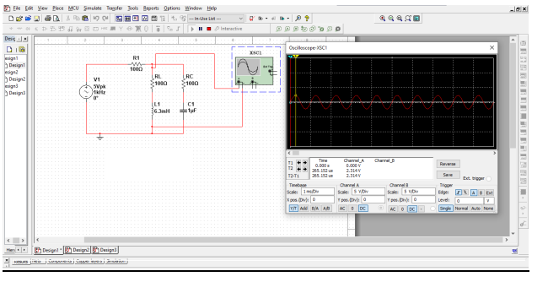

Table 1:

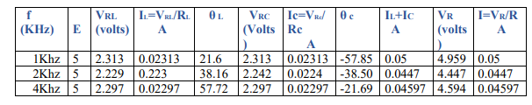

Calculation (Theoretically):

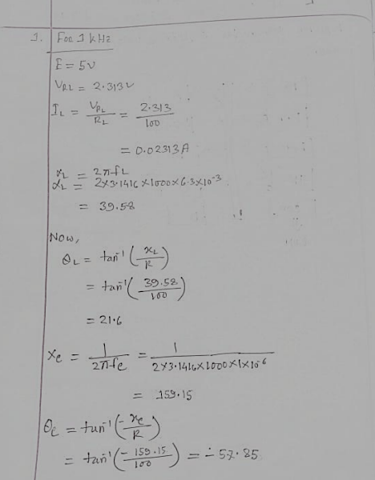

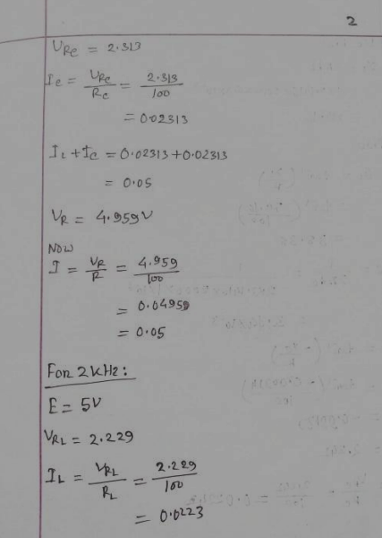

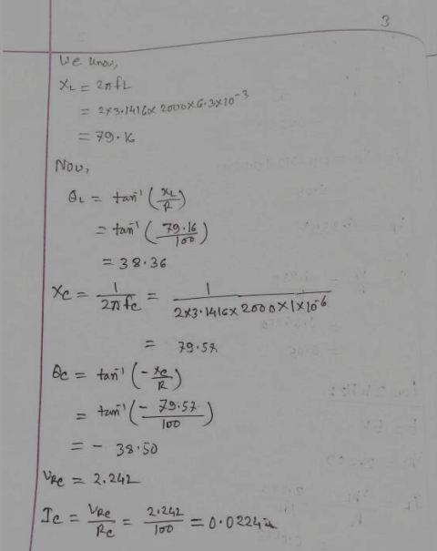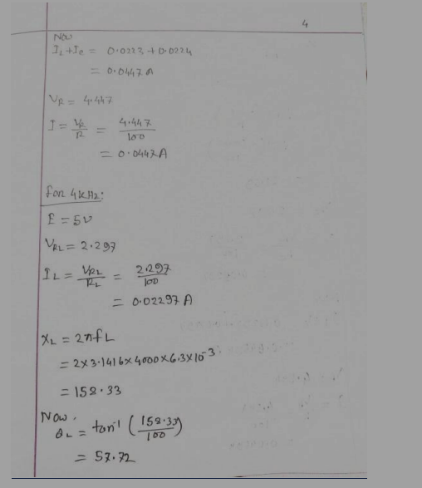

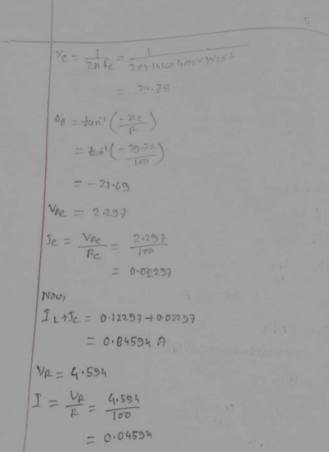

Discussion:

1. In this experiment, firstly we checked the oscilloscope & if the probs were perfect

so that we could start.

1. Then we connected the probs to the channels & gave frequency to the function

generator to get respective sinusoidal wave.

1. After doing all the steps, we got a value which was very close to our expected value.

Conclusions: Analyzing of RLC parallel circuit & verification of KCL in AC circuits are done in this experiment. So the experiment is successful.

Reference:

1. R.M. Kerchner and G.F. Corcoran, “Alternating Current Circuits”, John Wiley & Sons, Third Ed., New York, 1956